project #2: Image Stitching

B07902129 何政勳

1. Feature Detector
   1. Harris corner detector was implemented using OpenCV and numpy.
   2. The kernel size for gaussian blur is 5.
   3. The responsive threshold was set to 0.005 with maximum equals 1.

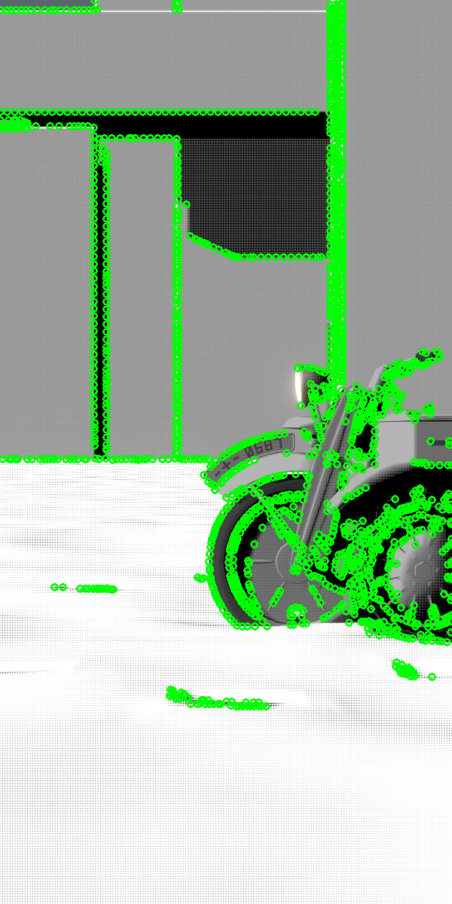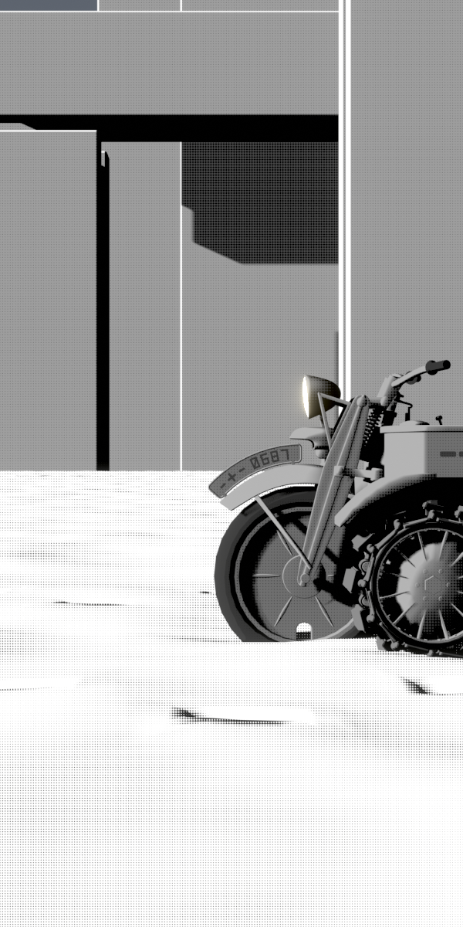

Feature points

Original image

1. Feature Descriptors and Matching
   1. The descriptor of a feature point was the flatten box around the point with 5px width.
   2. Matching started from the top 25 responsive feature points from two images and gradually increased the searching space.

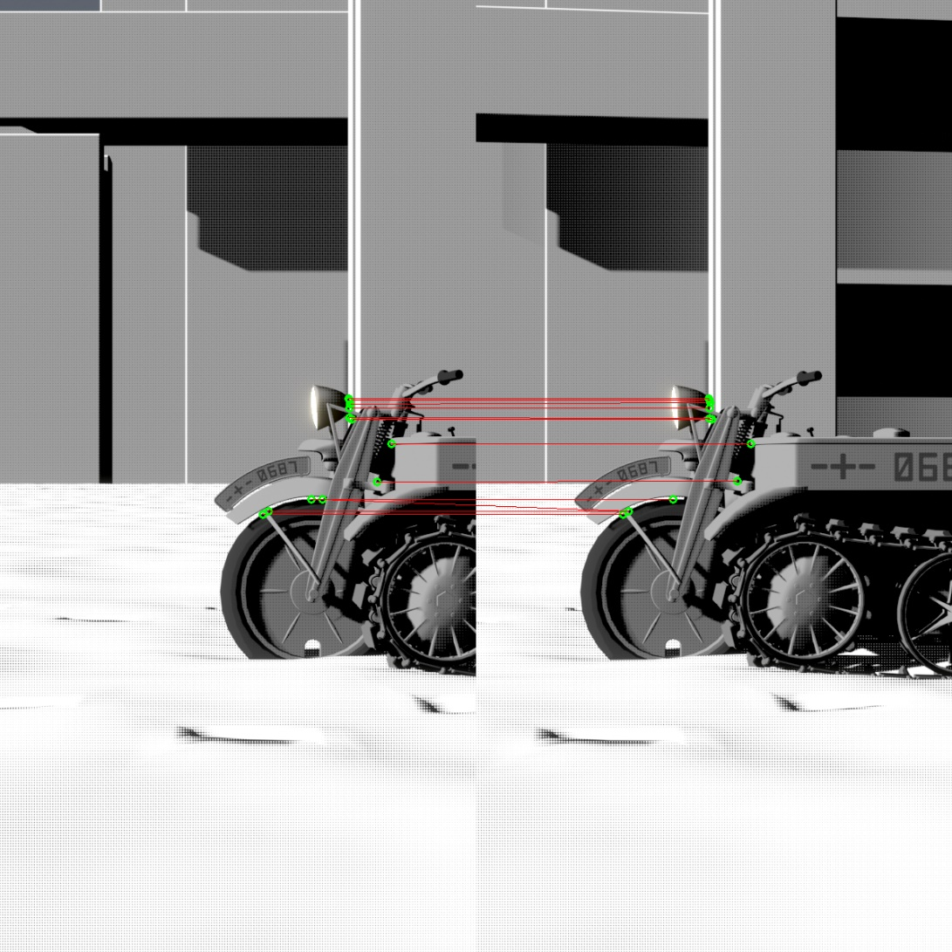

Matched features

1. Stitch
   1. The images as well as the feature points were wrapped cylindrically based on the focal length.
   2. 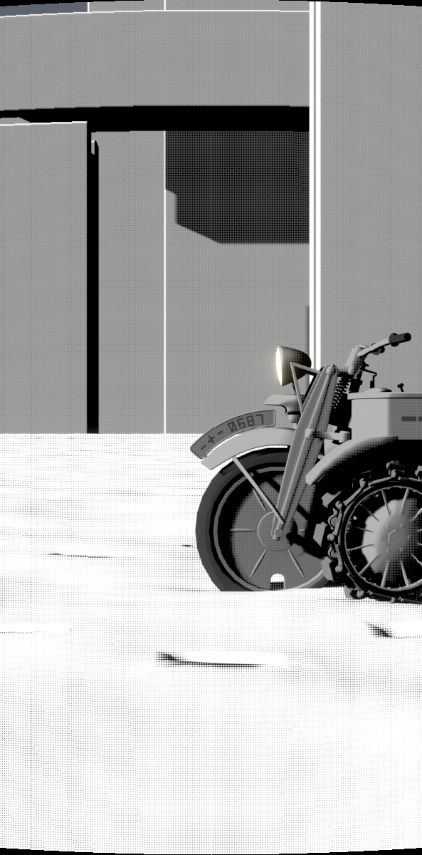The translation was calculated using a method similar to RANSAC. Instead of randomly picked a subset of matched points, I tested through all the matched points.

Cylindrical wrapped image

1. Original Images

|  |  |  |  |  |
| --- | --- | --- | --- | --- |
|  |  |  |  |  |

1. 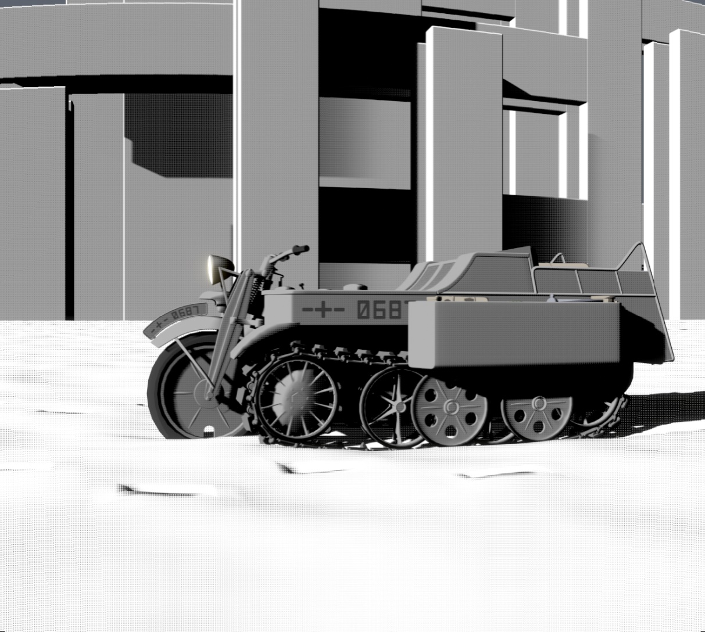Result
2. Discussions

Since adaptive non-maximal suppressions of feature points wasn’t implemented, the feature points after sorted were near to each other, causing some mis-matching on the results of different image sets.